This study group will explore the lives of Mexican muralist painter, Diego Rivera and his first wife, Russian artist, Angelina Beloff while living in France between 1910 and 1920. Presentation and discussion will be focus on exactly a moment of great artistic transformation in Paris, the 1910s. We will read Elena Poniatowska’s novel, Dear Diego. The novel acknowledges the professional and private life of Diego and Beloff when they met Picasso, Léger, Modigliani, Chagall, Mondrian, and numerous important artists of the time. In Dear Diego, Poniatowska highlights the "pull" of Mexico for Diego, and the reason for his return in 1921 which corresponds to the period of national reconstruction under President Obregon after the Mexican Revolution of 1910. This movement of national reconstruction brought about a diverse and active artistic climate in which the Mexican government sponsored programs such as the legendary mural projects under the directorship of the Minister of Education, José Vasconcelos.

Readings:

Dear Diego by Elena Poniatowska. Katheryn Silver, translator. New York: Pantheon Books, 1986.

Suggested readings:

Beloff, Angelina. Memorias. México: Secretaría de educación Pública, 1986.

The Diary of Frida Kahlo. An Intimate Portrait. introduction by Carlos Fuentes and with essay and commentaries by Sarah Lowe. New York: H. Abrams, 1995

Additional reading:

Tinísima by Elena Poniatowska. Mexico City: Ediciones Era, 1992
Borders by Gloria Anzaldúa
"Letters from Tina Modotti to Edward Wetson".

Slides of works by: Diego Rivera, Angelina Beloff Maria Blanchard, Frida Kahlo and Tina Modotti.

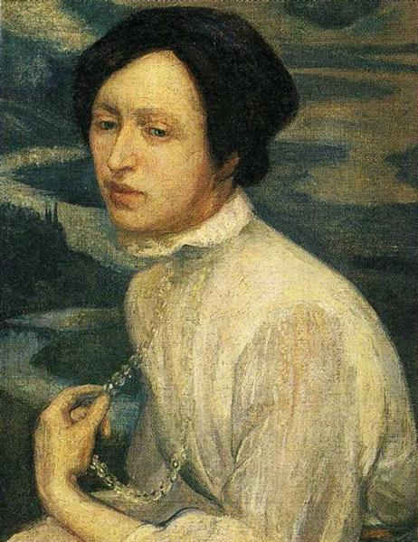

Angelina Beloff by Diego Rivera 1909, oil canvas.

Tentative reading schedule:

Week 1: Introduction to the course.

Readings: The Cubist Paintings of Diego Rivera, Politics and Place.

Link:

https://culturacolectiva.com/art/the-forgotten-lover-of-diego-rivera-who-proved-to-be-a-better-artist-than-frida-kahlo

Week 2:

Dear Diego, Postscript, page 89 and 3-9.

https://www.latinamericanart.com/en/artist/angelina-beloff/

Week 3:

Dear Diego, pp. 10-25.

https://www.diego-rivera.net/motherhood-angelina-and-the-child-diego/

Week 4:

Dear Diego, pp. 26-44.

https://www.twtd.co.uk/wiki/Angelina_Beloff

Week 5:

Dear Diego, pp. 45- 57.

http://museoblaisten.com/en/Artista/62/Angelina-Beloff

Week 6:

Dear Diego, pp. 58-69

https://glasstire.com/2009/07/10/diego-rivera-the-cubist-portraits-1913-1917-at-the-meadows-museum/

Week 7:

Dear Diego, pp. 70-83

https://www.scribd.com/document/452666386/Angelina-Beloff-Munecos-Animados-MX

Week 8:

Dear Diego, pp.84-87.

https://www.arteinformado.com/agenda/f/angelina-beloff-trazos-de-una-vida-59416

https://artoftherussias.wordpress.com/2012/04/14/angelina-beloff/

https://www.academia.edu/8508748/Man_at_the_Crossroads_Diego_Rivera_s_Mural_at_Rockefeller_Center

Bibliography

Amador, Raysa E. and Mireya Perez Bustillo. The Female Body Perspectives of Latin American Artists. Conn: Greenwood Press, 2002.

Beloff, Angelina. Memorias. México: Secretaría de educación Pública, 1986.

Bezhanova, Olga and Raysa E. Amador. Intersectional Feminism in the Age of Transnationalism: Voices from the Margin. Lanham, Md.: Lexington Books, 2021.

Billeter, Erika, Editor. The Blue House. The World of Frida Kahlo. Washington: University of Washington Press, 1993.

. Billeter, Erika, editor.Self-portrait in the Age of Photography. Photographers reflecting their own image. Switzerland: Musee cantonal des Beaux-Arts Lausanne Benteli Verlag Bern, 1985.

Borsa, Joan. "Frida Kahlo: Marginalization and the Critical Femmale Subject." Third Text(London) 12 (Autumn, 1990): 21-40.

Calderón, Hector, and José David Saldívar,eds. Criticism in the Boderlands. Durham: Duke University Press, 1991.

Constantine, Mildred. Tina Modotti, A Fragile Life. San Francisco: Chronicle Books, 1993.

Frida Kahlo and Tina Modotti. Laura Mulvey and Peter Wollen. Exhibition Catalogue. London: Whitechapel Art Gallery, 1982.

Dow Adams, Timothy. Telling Lies in Modern American Autobiography.North Carolina: The University of North Carolina Press, 1990.

Franco, Jean. Plotting Women. Gender and Representation in Mexico. New York:
Columbia University Press, 1989.

______, The Decline and Fall of the Lettered City: Latin America in the Cold War. Cambridge, Mass.: Harvard Univ. Press, 2002.

Giffords, Gloria. Mexican Folk Retablos: Masterpieces on Tin. Tucson: Tucson: University of Arizona Press, 1974.

Heilbrum, Carolyn. Writing Woman's Life. New York: W.W. Norton & Co.,1988.

Herrera, Hayden. Frida. A Biography of Frida Kahlo. New York: Harper and Row, 1983.

Hooks, Bell. Art on My Mind. Visual Politics. New York: The New Press,1995.

Hook, Margaret. Tina Modotti. Photographer and Revolutionary. London:Harper Collins Publishers, 1993.

Lowe, Sarah. Tina Modotti. Photographs. New York: H. Abrams, 1995.

. "The Immutable Still Lifes of Tina Modotti." History of Photography. (Women in Photography issue) 18, no. 3 (Autumn 1994): 205-10.

Miller, Nancy. Getting Personal. Feminist Occasions and Other Autobiographical Acts. New York: Routledge, Chapman and Hall, Inc.,1991.

Molloy, Sylvia. "Introduction." Women's Writing in Latin America. Boulder: Westview, 1991.

Poniatowska, Elena. Querido Diego, te abraza Quiela. México: Era, 1978.

. Dear Diego. Katheryn Silver, translator. New York: Pantheon Books, 1986.

. "Literature and Women in Latin America." Women's Writing in Latin America. Boulder: Westview, 1991.

Ramos-Arbolí, Irene. “En búsqueda de la verdadera Angelina Beloff: tras la letra y la pintura.” Divergencias, Volumen 14, número 1, (primavera 2016): 89-97.

Stark, (Rule), Amy, ed. "The Letters from Tina Modotti to Edward Wetson." The Archive (Tucson, Arizona) no. 22 (January 1986): 4-81.

Rivera, Diego. My Art, My Life. with Gladys March. New York: TheCitadel Press, 1960.

Robinson, Ione. A Wall to Paint On. New York: E.P. Dutton and Co., Inc.,1946.

Raoul, Valerie. "Women and Diaries: Gender and Genre," Mosaic 22/3(Summer 1989): 57-65.

Schaefer, Claudia. Textured Lives. Women, Art, andRepresentation in Modern Mexico. Tucson: University Arizona Press, 1992.

Sifuentes-Jáuregui, Ben. “Gender and Representation in Contemporary Latin American Culture.” Latin American Review Vol. 29, No. 57 (Jan.-Jun. , 2001) 71-86.

Smith, Sidonie and Julia Watson, eds. Women, Autobiography, Theory: A Reader. Madison: University of Wisconsin Press, 1998.

Todorov, Teztan. Literatura y significación. Barcelona: Editorial Planeta, 1971.

Varo, Remedios. Lady Milagro. Mexico: n.e., 1942.

Waugh, Patricia. Feminine Fictions. Revisisting the Postmodern. NewYork: Routledge, 1989.

Wolfe, Betram. The Fabulous Life of Diego Rivera. New York: Stein & Day, 1963.

Zamora, Martha. Frida Kahlo: The Brush of Anguish. San Francisco: Chronicle Books, 1990.

