Latin for Developing Translators
Fall, 2022
Diana Smith
desdian@gmail.com

In the next 11 weeks, we continue to work our way through Chapters 10- 16 of “Wheelock’s Latin.” We will encounter more declensions, conjugations, and delightful pronouns, relative, demonstrative, and personal, oh my!

In this third session, we will also begin to translate some longer and more complex texts, including some of Ovid’s poetry, Augustine’s musings, and Cicero’s most accessible sentences.

If you were in the previous sessions, then come ahead and let’s do it again. If you were not, and have learned Latin along the way, please email me and we’ll see if you are ready to join.

Here is a tentative sequence of the classes. I will undoubtedly adjust this as we get a feel for how quickly or slowly we need to go.

Week One - Review of all material from Chapters 1-9 in Wheelock.

Week Two - Chapter 10: 4th Conjugation and -io verbs of the 3rd Conjugation

Week Three - Chapter 11: Personal Pronouns

Week Four - Chapter 12: The Perfect Active System

Week Five - Chapter 13: Reflexive Pronouns and possessives

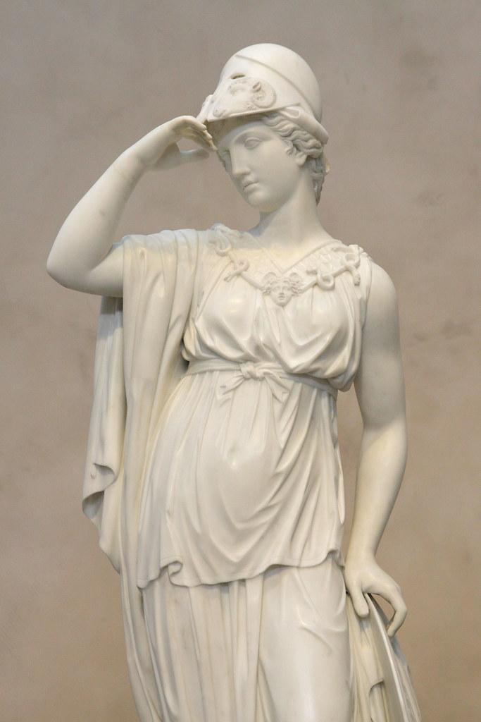

Week Six - Chapter 14: I-stems nouns and all those ablatives!

Week Seven - Chapter 15: Numbers and more ablatives!

Week Eight - Chapter 16: 3rd declension adjectives

Week Nine - Review of all the grammar of the semester

Weeks 10 and 11 - Putting It All Together! Translating!

